**Artificial Intelligence and Data Science Department.  
Web Computing / Even-Sem 2021-22 / Experiment 2.  
_________________________________________________________________**

**YASH SARANG.  
47 / D11AD.  
EXPERIMENT - 2.  
_________________________________________________________________**

**Aim:**

To create an HTML page with CSS attributes using Colour, Background, Fonts, Tables, Lists, CSS3 selectors, Pseudo classes, and Pseudo elements.

**_________________________________________________________________**

**Theory:**

**Cascading Style Sheets (CSS)** is a stylesheet language used to describe the presentation of a document written in HTML. It is used to style and layout web pages. For example,

To alter the font, color, size, and spacing of your content split it into multiple columns, or add animations and other decorative features.

**Fonts:**

Using this we add different fonts to our web page according to our

requirement or basically for beautification purposes.

There are 5 generic font families:

1. Serif

2. Sans-serif

3. Monospace

4. Cursive

5. Fantasy

Syntax:

*.p1 {*

*font-family: "Times New Roman";*

*}*

**Lists:**

In HTML, there are two main types of lists:

● unordered lists (<ul>) - the list items are marked with bullets

● ordered lists (<ol>) - the list items are marked with numbers or letters

The CSS list properties allow you to:

● Set different list item markers for ordered lists

● Set different list item markers for unordered lists

● Set an image as the list item marker

● Add background colors to lists and list items

The list-style-type property specifies the type of list item marker.

Syntax:

*ul.b {*

*list-style-type: square;*

*}*

**Pseudo Class:**

A pseudo-class is used to define a particular state of an element.

For example, it can be used to:

● Style an element when a user mouses over it

● Style visited and unvisited links differently

● Style an element when it gets focus

The syntax of pseudo-classes:

*selector:pseudo-class { property: value; }*

**Color:**

Colors are specified using predefined color names, or RGB, HEX, HSL, RGBA, and HSLA values.

You can set the background color for HTML elements:

Syntax :

*<h1 style="background-color:DodgerBlue;">Hello World</h1>*

*<p style="background-color:Tomato;">Lorem ipsum...</p>*

**Conclusion:**

We have successfully learned to create an HTML page with CSS attributes.

**_________________________________________________________________**

**Code Snippets:**

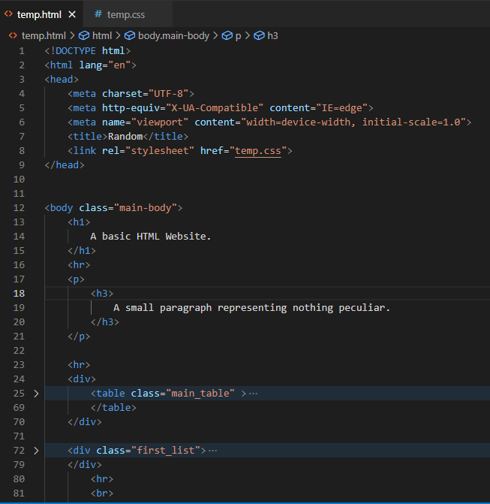

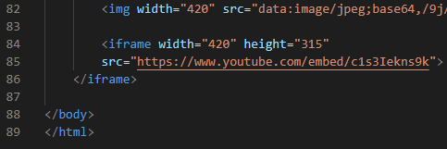**_________________________________________________________________**

**Output:**

